

**Research Internship Programme**

Cohort 8.0

**Final Report**

Exploring Heat Stroke Risk Using NASA POWER Temperature Data in R

**Name of Intern**

Abrar Labib

**Department**

GeoSpatial Health Research Group (GHRG)

**Date of Submission**

25th March, 2025

1. **Introduction**

Climate change has caused serious health hazards paaticularly among the vulrenable groups and as a consequence, severe heat events are becmoing quite often nowadays. Heat-stroke; a severe heat-related illness is increasing at a quite alarming rate commonly in the areas where temperatures are high for extended periods of time. Analyzing temperature patterns and proper identification of high-risk geographical zones are the prerequisities for establishing efficient warming mitigation strategies.

Temperature data derived from NASA’s prediction of Worldwide Energy Resources (POWER) platform has been examined to analyze and identify those patterns that significantly contribute to heat stroke risk in a specific geographical area. R and geospatial mapping tools such as **(Arcmap 10.8)** will be employed to depict temperature fluctuations and emphasize places experiencing excessive heat. The outcome of this study shows us the heat sensitive zones of the desired region, helps us understanding the casual annual trend of temperature over the years etc. and finally could guidinitiatives for public e some of recommendations for mitigating heat-stroke sensitiveness.

1. **Methods**

Descriptive Statistical Analysis methods were adopted to determine the Mean, Median, Mode of the dataset. Monthly trends and variations were analyzed and identified via this method. Extreme temperature days (e.g., above 40°C) were identified and their frequency was examined. Besides, using literature-based thresholds (e.g., days with temperatures above 40°C), the number of high-risk days was estimated in order to justify the heat-stroke risk assessment. Temperature data and regional bounday shape files were analyzed under the criteria of extreme heat sensitiveness and were visualized for getting better insights.

**2.1 Data preprocessing**

Temperature data of a specific region (Rajshahi) were extracted from NASA’s POWER Data Viewer. The dataset included maximum daily temperature records spanning from 1 March, 2019 to 3 March, 2022 of Rajshahi division. The dataset thus downloaded was imported to R interface and basic preprocessings were implemented to ensure accuracy and data’s cleanliness . Further checks were done to sort out any missing value’s presence, existence of any infinite values etc. Variable (column) names were renamed in order to bring clarity to understanding. To improve data efficiency, extraneous columns were eliminated and data formats were standardized using necessary packages after installation in R Studio.

* 1. **Descriptive Stastical Analysis**

After analyzing the whole dataset, the key stastical paramters such as, mean, median, mode of daily maximum temperatuers were determined. Skewness and Kurtosis of the whole dataset were determined in order to figure out in what sort of order the dataset looks like. Then, To track changes in temperature variation and trends, seasonal and monthly averages were calculated. The frequency of extreme temperature days- those having maximum temperature of more than 40 degrees Celcius was noted.

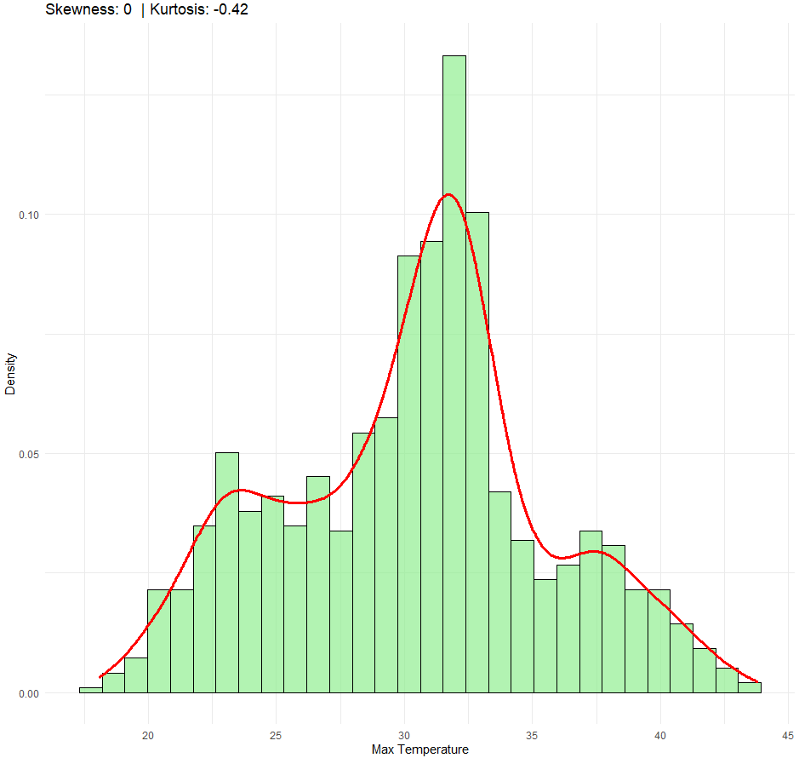

**Figure:** Skewness of the dataset

**2.3 Geospatial Visualization**

The ggplot2 and sf programs were used to create a geographic heatmap of the temperature distribution. Administrative boundary overlays were superimposed on the graphic to give context for regional temperature changes. To identify regions most at risk for heat stroke, high-temperature zones were indicated. NASA POWER provided LAT and LON of our region has a different csr value than that of the shape file offered by DIVA GIS. That’s why the highlighted region showed by the visualization of high-risk shows only Rajshahi district instead of whole rajshahi division. The population effect on heat wave found out to be less existent in this case. High temperature pr heat waves are independent of population density over our region of interest.

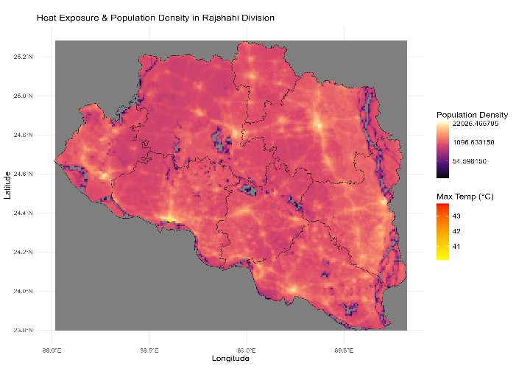 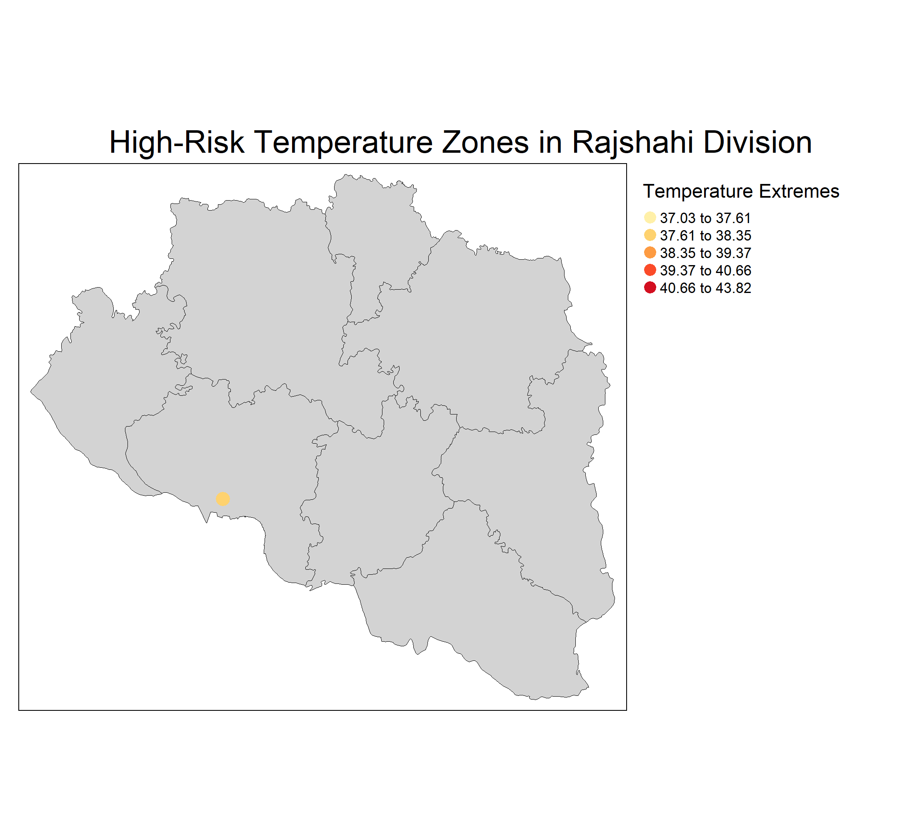**Figure:** Heat Exposure and Population Density of Rajshahi Division **Figure:** High-risk Temperature exposure Zones

### 2.4 Temporal Analysis

A time series visualization of daily maximum temperatures was developed using ggplot2 to identify trends and anomalies over the observation period. A rolling average technique was applied to smooth fluctuations and highlight significant deviations. The graphs shows that the average temperature in the upcoming days might shift a bit higher than than that of the recent times or past time. And also the temperature in April tops amongst all. Besides, the graph also shows a **clear seasonal variation**, with temperatures peaking around the middle months and dipping towards the end. Anomalies (marked in pink) indicate points where the temperature deviates significantly from expected patterns. These anomalies might be caused by climate fluctuations, extreme weather events or data irregularities.

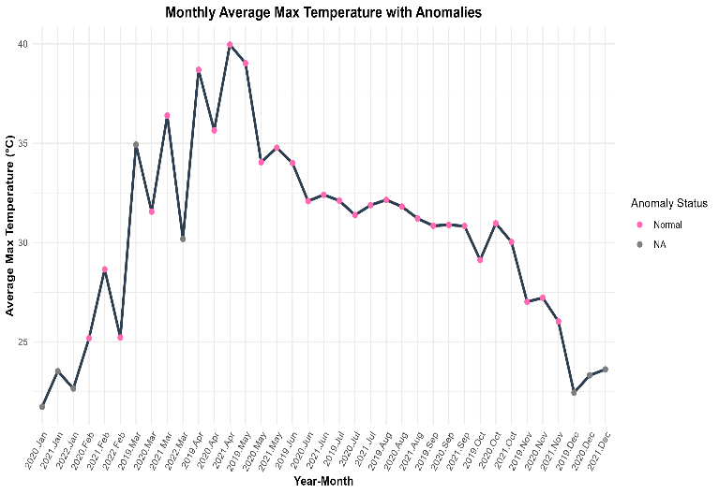 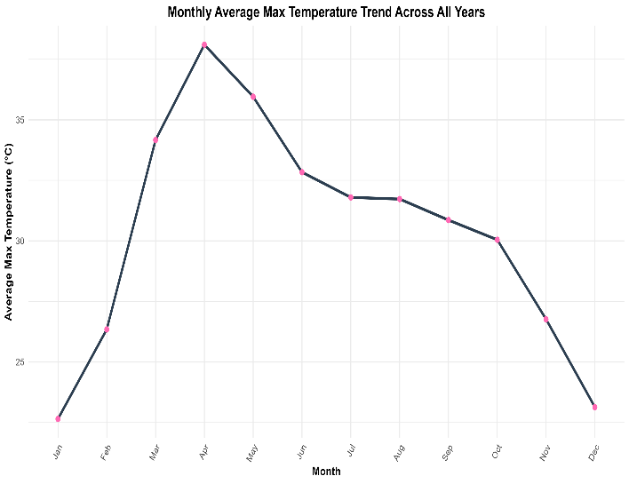

**Figure:** Anomalies in temperature data  **Figure:** Trend in temperature data across all years

### 2.5 Heat Stroke Risk Analysis

Based on the defined threshold, an estimated 39 days posed a significant heat stroke risk. This suggests a substantial public health concern, particularly in **specific seasons or months.** The results align with existing studies that highlight the increasing frequency of extreme heat events in Bangladesh.Heatmap shows that the April of 2019 was the most intense one.

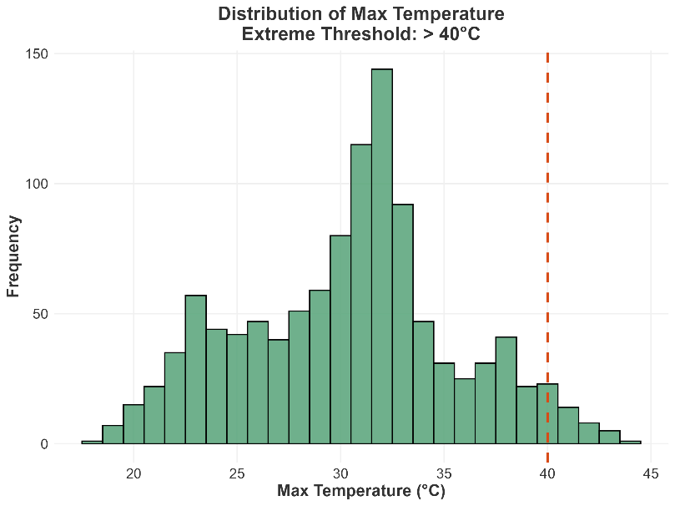

**Figure:** Max temperature distribution

The distribution appears somewhat right-skewed, suggesting that while most temperature values cluster around the 30–35°C range there are occasional extreme temperature events exceeding 40°C. The peak frequency is observed in the 30–32°C range where most readings are concentrated. The presence of extreme temperature events, though relatively infrequent. The presence of extreme temperatures beyond 40°C, though relatively rare, signifies critical instances of heatwaves which could have serious environmental, health and economic implications.

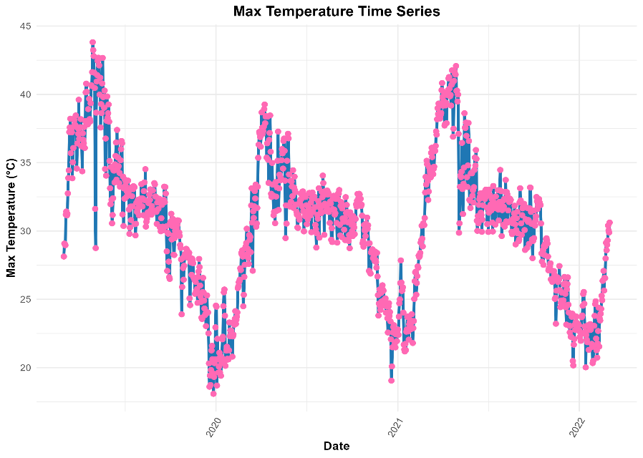

**Figure:** Max Temperature Trend over the years

The peaks and troughs align with typical **summer and winter cycles**, but long-term patterns might indicate **climate change effects**. The temperature follows a recurring seasonal trend, peaking around the same periods each year and dipping in others.

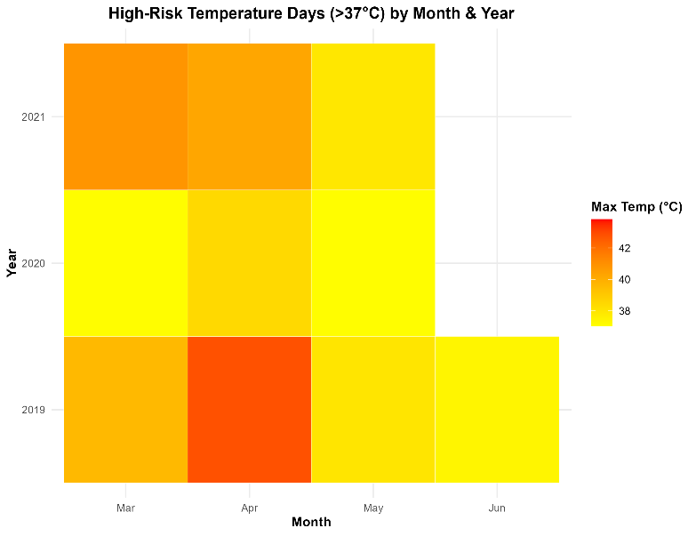

**Figure:** Heatmap of the max daily temperatures

The frequency of high-risk temperature days appears to fluctuate across years, with some months showing consistently high values. The color gradient from yellow to red indicates the intensity of high temperatures, with red areas signifying the highest recorded temperatures. March, April, and May are the months most affected by extreme heat.

1. **Result**

The geospatial analysis of the desired region (Rajshahi) denotes that severe temperature related isses are foreseen by their residents almost each year. While temperature stays reasonable within it’s relative boundary over all years throughout the months but sometime’s it crosses the threshold temperature leading to excessive discomfort. Specially in our dataset (2019-2022), the peak was seen in April month most of the cases. And the major heat waves were noticed when the temperatures were around 40 degrees or more.   
  
Population density across the Rajshahi division is quite unavoidable too. But our analysis doesn’t seem to bother regarding that much. Since we didn’t notice any positive relation between these two parameters. Our analysis brought the fact that the temperature within our time range topped during the April time of 2019. Also our statistical analysis showed that the average temperature thoughout the rime range was around in between 30-35 degree C.

1. **Recommendations:**

Primarily small-scale tree plantation programme would be the most feasible solution against fighting heat-stroke. Rapid increment of green spaces would greatly contribute towards heat waves.

In order to reduce the vulnerability among the peolpes, the peoples who spend most of their time under the sun should be focused. Their working hours should be shifted to other timings rather than the time of scorching sunlight. Besides, the government should implement initiatives to early warn the citizens through phone SMS beforehand regarding upcoming heat waves.   
Besides, areas those are mostly vulnerable to temperature sentiveness should be brought under mobile water cooling zones.

### Discussion

The findings of this study underscore the increasing risk of heat stroke in **selected region** due to rising maximum temperatures. The identification of extreme temperature days provides critical insights for public health planning and heat mitigation strategies. Seasonal patterns indicate that pre-monsoon and summer months exhibit heightened vulnerability, necessitating targeted interventions.

The geospatial analysis further highlights regions with the most severe temperature extremes, suggesting that urban heat island effects or geographical factors may contribute to localized warming. The study also emphasizes the importance of continued monitoring of temperature trends to assess the impact of climate change on heat exposure.

Overall, this analysis contributes to understanding heat stroke risks in Bangladesh and offers data-driven recommendations to mitigate adverse health effects associated with extreme heat events.